A Special Message to the Parishioners of St. Dominic Parish

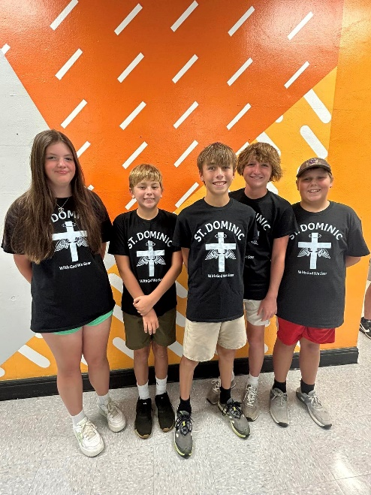
From the first day it was announced that I was to be pastor of St. Dominic Parish people have told me how proud they are of St. Dominic School and how important the school is to the parish and the wider community. There is no doubt that the school is a priority for the people of St. Dominic, and it is a legacy they have received from previous generations and one they want to pass on to future generations. As pastor I think the school is an essential part of our character and mission and it is my intention to keep the school open and growing. The school has excellent programs for education, and we will continue to reach for academic, intellectual, personal, and spiritual excellence. You will be happy to hear that our school admissions numbers are around four hundred and it is our intention to see that number increase to five hundred in the next couple of years. As well as providing an excellent academic program, the school is a place to be and that structure needs care also. Over the summer a lot of work has taken place in the interior of our school building with the painting of corridors, school entrance area, dining area, and the entrance to the gym.

I want to thank all those who helped move this work forward, including a review committee of Jenny O’Brien, Reggie Angel, Rich Hafner, Tom Mattei, and Dennis Eagan. All of this work was made possible by a legacy we received that was directed by the donor to improving the school. Through a grant from the State of Ohio we have been able to update our phone and intercom systems, add sixty-six security cameras and improve the security lighting around the exterior of the building. Next year it is our intention to redevelop the old convent area into an attractive STEAM Wing (Science, Technology, Engineering, Arts, Mathematics) and Art studio, to move and improve the teachers’ lounge to make it more accessible and comfortable, and to redevelop our front office area. After that we will tackle new LED lighting and painting of the classrooms and add air conditioning to the cafeteria and gym. When I get firm numbers on the cost of this renovation, I will let you know through the bulletin. If you think you can financially support this work, don’t be shy, Fr. Jim, Fr. Chris and I would love to hear from you. Any gift given to the school for this purpose is not subject to the archdiocese assessment of 9.5% so the total amount of the gift goes to the school. We will invest in our school because investing in our school is investing in our families, our children, our parish, and our future. The future doesn’t just happen, people make it happen, and those people are you! Your vision, your commitment, your dedication, and
your sacrifice make a difference – for generations.
Thanks for all you do to support St. Dominic Parish and School.

Go Blackhawks!

Fr. Ben

